**What are the Main Significant Differences between Hospitals in Different Markets?**

Hospitals in the three markets perform differently. Based on the analysis, it can be concluded that hospitals in the high market perform poorly. Such hospitals are smaller, have fewer staff, and lower cost revenue and profit. Hospitals in the high market also treat fewer patients compared to others. The analysis further reveals that hospitals in the moderate market performed better than those in low and high markets. They tend to be larger, employ more staff, and achieve higher revenues and net benefits. Lastly, hospitals in the low competition performed better than those in the high market competition, but poorly compared to those in moderate competition.

**Use the Density Curves and Compare Hospitals' Costs and Revenues Between three Markets.**

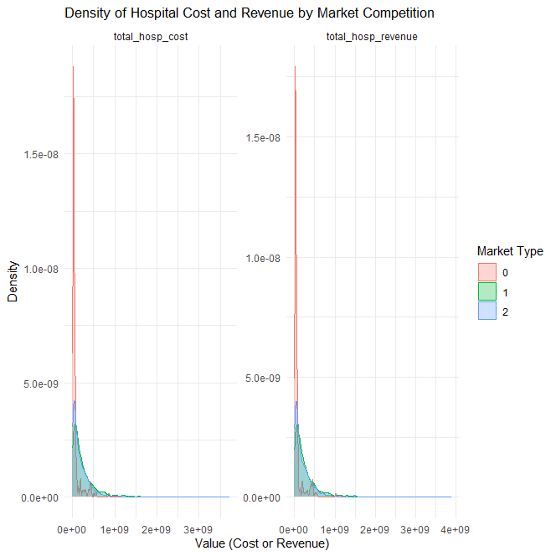

From the plotted density curve, it can be concluded that hospitals in the high market competition spent less cost and earn less revenue. Hospitals in the moderate market competition spend more and earn more revenue. Lastly, hospitals in the low market competition spend less amount than those in the moderate market but more than those in the high market competition, and they earn higher revenue than those in the high market but less than those in the moderate market.

**What is the Impact of Being in a Highly Competitive Market on Hospital Revenues and Costs?**

Hospitals in the highly competitive market incur less cost, and they earn less revenue. Being in a highly competitive market does not have a positive impact on hospital benefits. Hospitals in highly competitive areas have limited facilities and financial hence they serve fewer patients, and this generates less revenue.

**Variation of Medicaid and Medicare Patients in the three Markets**

|  |  |  |
| --- | --- | --- |
| Comparison | Variable | P value |
| High vs Moderate | Medicare Ratio | 2.247395e-20 |
| High vs Moderate | Medicaid Ratio | 9.397292e-01 |
| High vs Low | Medicare Ratio | 6.158568e-09 |
| High vs Low | Medicaid Ratio | 3.277809e-01 |

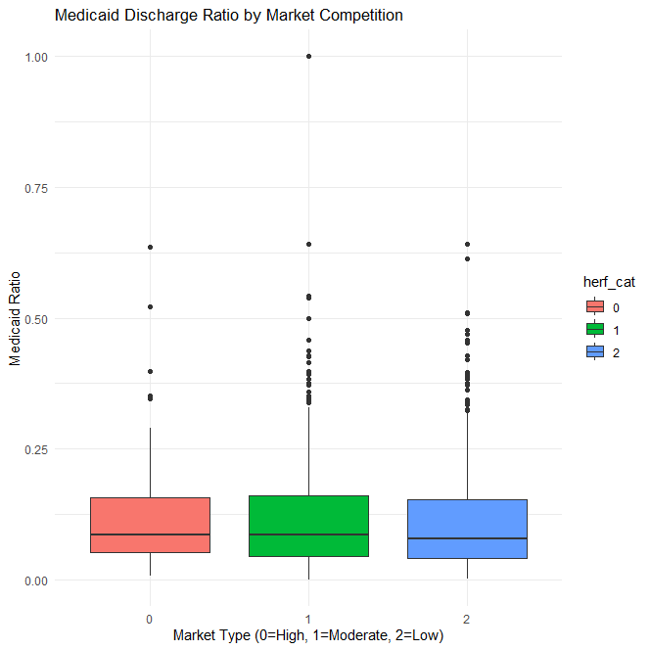

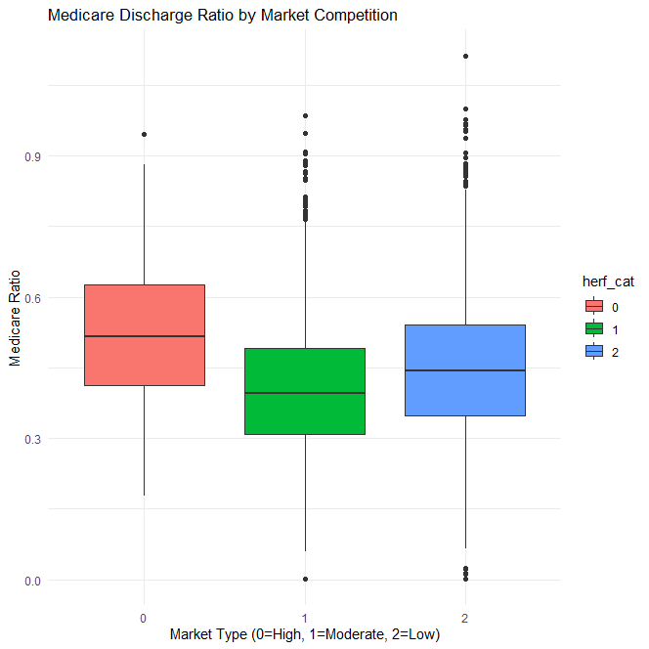

The p-value for High vs Moderate Medicare ratio is 2.247395e-20. This implies there are significant statistical differences between the Medicare patients served in high and moderate market hospitals. The p-value for High vs Low Medicare ratio is 6.158568e-09. These findings further reveal statistical differences between Medicare patients in high and moderate market hospitals, and the Medicare boxplot further supports these findings. The p-value for High vs Moderate Medicaid ratio is 9.397292e-01, while that for High vs Low Medicaid ratio is 3.277809e-01. The findings reveal that there are no significant differences between the number of Medicaid patients served in all market hospitals, and the Medicaid boxplot further supports these findings.

Market competition affects Medicare discharges significantly. Hospitals in highly competitive markets serve significantly more Medicare patients than those in moderate and low-competitive markets. These findings imply that hospitals in competitive markets attract and serve more Medicare patients compared to those in moderate and low markets. On the other hand, Medicaid discharge is not affected by market competition. There is no significant difference in the number of Medicaid discharges among the patients in all markets. These findings imply that the number of Medicaid patients to be served is not affected by market competition but rather shaped by government policies.

**Table 3. Comparing hospital characteristics and market, 2011 and 2012**

|  |  |  |  |  |  |  |  |  |  |  |
| --- | --- | --- | --- | --- | --- | --- | --- | --- | --- | --- |
|  | High Competitive Market | | | Moderate Competitive Market | | | Low Competitive  Market | | | ANOVA/Chi-Sq (results) |
| **Hospital Characteristics** | N | Mean | STD | N | Mean | STD | N | Mean | STD |
| 1. Hospital beds | 219 | 131 | 386 | 1332 | 421 | 594 | 1479 | 374 | 562 | 2.378808e-11 |
| 1. Number of paid Employee | 219 | 500 | 813 | 1324 | 1570 | 1955 | 1470 | 1309 | 1722 | 6.999629e-16 |
| 1. Number of non-paid Employee | 0 | NaN | N/A | 25 | 35.9 | 31 | 35 | 47.0 | 97.1 | 5.825674e-01 |
| 1. Internes and Residents | 22 | 38.3 | 45.6 | 423 | 112.2 | 176 | 480 | 86.6 | 150 | 1.306161e-02 |
| 1. System Membership | 219 | 0.4 | 0.49 | 1332 | 0.6 | 0.49 | 1479 | 0.6 | 0.48 | n/a |
|  |  |  |  |  |  |  |  |  |  |  |
| 1. Total hospital cost | 219 | 73687086 | 121326585 | 1332 | 255520655 | 341985822 | 1479 | 201077823 | 267368743 | 1.613839e-17 |
| 1. Total hospital revenues | 219 | 77700145 | 130293994 | 1332 | 270841127 | 366185059 | 1479 | 214430928 | 290476695 | 6.272197e-17 |
| 1. Hospital net benefit | 219 | 4013058 | 19021599 | 1332 | 15320472 | 39434375 | 1479 | 13353106 | 41078313 | 3.886666e-04 |
|  |  |  |  |  |  |  |  |  |  |  |
| 1. Available Medicare days | 219 | 5377 | 999.4 | 1324 | 18984 | 20298 | 1472 | 16793 | 19219 | 6.156443e-21 |
| 1. Available Medicaid days | 217 | 1416 | 4429 | 1317 | 6554 | 10677 | 1451 | 4812 | 8165 | 3.102218e-15 |
|  |  |  |  |  |  |  |  |  |  |  |
| 1. Total Hospital Discharge | 219 | 2608 | 5065 | 1326 | 11101 | 11741 | 1472 | 9121 | 10397 | 1.293215e-26 |
| 1. Medicare discharge | 219 | 1068 | 1754 | 1324 | 3782 | 3653 | 1472 | 3435 | 3623 | 2.303622e-24 |
| 1. Medicaid discharge | 217 | 310 | 749 | 1314 | 1324 | 1962 | 1448 | 1067 | 1605 | 3.601472e-15 |
|  |  |  |  |  |  |  |  |  |  |  |
| 14. Herfindahel index | 219 | 1.96 | 0.188 | 1332 | 1.67 | 0.666 | 1479 | 1.70 | 0.639 | 1.188425e-09 |

